**Report about conducted load test**

**Date:** 04/07/2022

**Author:** Vladyslav Kliucharov

**Application:** BlogEngine.NET version 3.2

**Environment:** Test Environment VirtualBox (Version 6.1.34 r150636 (Qt5.6.2))

**Test Environment configuration(RAM, CPU etc.):**

|  |  |
| --- | --- |
| **Processor** | 11th Gen Intel(R) Core(TM) i7-1185G7 @ 3.00GHz 3.00 GHz (4 core) |
| **RAM** | 4 GB |
| **Hard Disk** | 60 GB |
| **Operating System** | Windows 10 Enterprise (21H2) |

1. **Why such testing was conducted:**

The report is included two methods of testing:

1. Smoke testing - was conducted to verification that the crucial functions of a program can be run and executed in the main workflow

2. Scalability Testing- was conducted to define and ensure that the system can handle the scaling of CPU and RAM performance goals

1. **Test script description:**

The features to be tested have been logically grouped to be covered by 3 threads of users "Admin script", "Editor script" and "Anonymous script". These scenarios were combined in one script followed by load requirement analysis for the modules. The below table captures the features covered by each script. The implement probabilities usage was divided by percentages for all threads (shown below tables):

|  |  |
| --- | --- |
| **Admin script** | **Editor script** |
|  |  |

|  |  |  |
| --- | --- | --- |
|  | **Anonymous script** |  |
|  |  |  |

Scenario to implement probabilities usage:

|  |  |
| --- | --- |
| 1. Home Page: 15%  2. Open Random Date: 10%  3. Open Predefined Date: 30%  4. Search by Name: 30%  5. Open Large Calendar: 10%  6. Open Contacts: 5% | 1. Open Random page (yes/no): 50% / 50%  2. Open post (yes/no): 80% / 20%  3. Random or First (yes/no): 65% / 35%  4. Comment (yes/no): 20% / 80% |

1. **Tests:**  
   **Test run preconditions:**

* CSV file with Random dates
* Warmup script was running before each test run
* Before each new test script run, the webserver was reloaded, the test executed in NON-GUI mode
* Using results of the testing from Task 7 define regular load
* Define general Key Performance Indicators (KPI), and get their basic value using the results from Task 7
* There were used 6 Scale Models**:**

|  |  |  |
| --- | --- | --- |
|  | **CPU** | **RAM** |
| **Scale Model 1** | 1 | 8GB |
| **Scale Model 2** | 1 | 12GB |
| **Scale Model 3** | 1 | 16GB |

|  |  |  |
| --- | --- | --- |
|  | **CPU** | **RAM** |
| **Scale Model 4** | 2 | 8GB |
| **Scale Model 5** | 3 | 12GB |
| **Scale Model 6** | 4 | 16GB |

Scenarios model (was used similarly for all scale) the value was getting from Task7 regular load model by got results of previous test runs

|  |  |  |  |  |  |
| --- | --- | --- | --- | --- | --- |
| **Thread Group** | **Maximum number of simultaneous users** | **Ramp-Up period** | **Test duration** | **Probabilities usage** | **Number of posts quantity** |
| Thread Group (Admin users) | 2 | 100 | 600 (sec.) | Pre-Defined | 1000 |
| Thread Group (Editor users) | 10 | 50 | 600 (sec.) | Pre-Defined | 1000 |
| Thread Group (Anonymous users) | 35 | 175 | 600 (sec.) | Pre-Defined | 1000 |

1. **Short summary on conducted tests:**

The server worked not stable according to the received test results by 3 runs in Task7 CPUs is grooving to 100% load, the comfort zone was defined is 45 users. Main parameters for marks are Throughput (Req/s), Errors (Total), Response time (Average), Response time (Median), 90th Percentile (Mean), 95th Percentile (Mean), load model Task 7 uses the parameters below and the best result from 3 runs

|  |  |  |  |  |  |  |  |  |
| --- | --- | --- | --- | --- | --- | --- | --- | --- |
|  | **CPU** | **RAM** | **Throughput (Max)** | **Errors (Total)** | **Response time (Average)** | **Response time (Median)** | **90th Percentile (Mean)** | **95th Percentile (Mean)** |
| Load model (Task 7) | 2 Core | 8 GB | 13.00 Req/s | 350 | 3.59 ms | 2.89 ms | 18.7 sec | 20.9 sec |

1. **Detailed test results:**

‘Task8’ scripts were running 12 times, according to the scalability CPU testing results, the results and behavior were different:

|  |  |  |  |  |  |  |  |  |  |  |  |  |
| --- | --- | --- | --- | --- | --- | --- | --- | --- | --- | --- | --- | --- |
|  | **Run 1 Scale Model 1** | **Run 2 Scale Model 1** | **Run 1 Scale Model 2** | **Run 2 Scale Model 2** | **Run 1 Scale Model 3** | **Run 2 Scale Model 3** | **Run 1 Scale Model 4** | **Run 2 Scale Model 4** | **Run 1 Scale Model 5** | **Run 2 Scale Model 5** | **Run 1 Scale Model 6** | **Run 2 Scale Model 6** |
| **CPU** | 1 Core |  | 1 Core |  | 1 Core |  | 2 Core |  | 3 Core |  | 4 Core |  |
| **RAM** | 8 GB |  | 12 GB |  | 16 GB |  | 8 GB |  | 12 GB |  | 16 GB |  |
| **Throughput (Max)** | 16.80 Req/s | 17.00 Req/s | 17.20 Req/s | 16.80 Req/s | 17.20 Req/s | 19.40 Req/s | 16.40 Req/s | 16.20 Req/s | 17.00 Req/s | 16.60 Req/s | 17.40 Req/s | 16.20 Req/s |
| **Errors (Total)** | 0 | 0 | 0 | 4 | 1 | 4 | 132 | 128 | 186 | 142 | 170 | 246 |
| **Response time (Average)** | 3.87 ms | 3.32 ms | 3.46 ms | 3.68 ms | 3.83 ms | 3.61 ms | 2.60 ms | 2.85 ms | 3.29 ms | 2.97 ms | 3.12 ms | 3.21 ms |
| **Response time (Median)** | 2.89 ms | 2.58 ms | 2.49 ms | 2.78 ms | 2.91 ms | 2.66 ms | 2.03 ms | 2.35 ms | 2.51 ms | 2.22 ms | 2.37 ms | 2.44 ms |
| **90th Percentile (Mean)** | 1.49 sec | 2.72 sec | 2.95 sec | 1.76 sec | 1.64 sec | 2.11 sec | 20.9 sec | 22.2 sec | 6.92 sec | 17.3 sec | 6.42 sec | 7.66 sec |
| **95th Percentile (Mean)** | 1.86 sec | 3.41 sec | 3.93 sec | 2.20 sec | 2.16 sec | 2.57 sec | 21.7 sec | 26.9 sec | 7.33 sec | 22.2 sec | 6.87 sec | 9.31 sec |

**Test Run #1 (Scale Model 1)**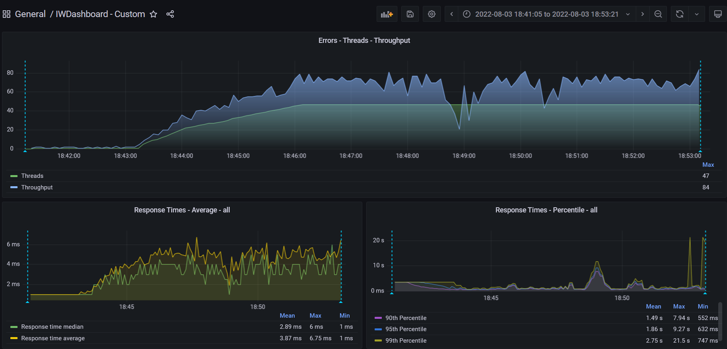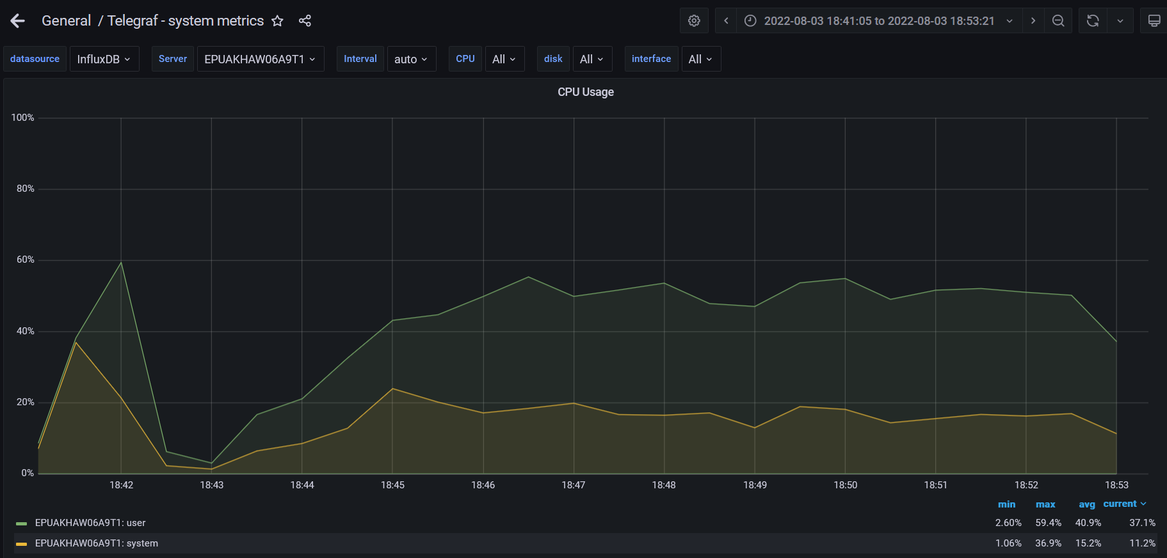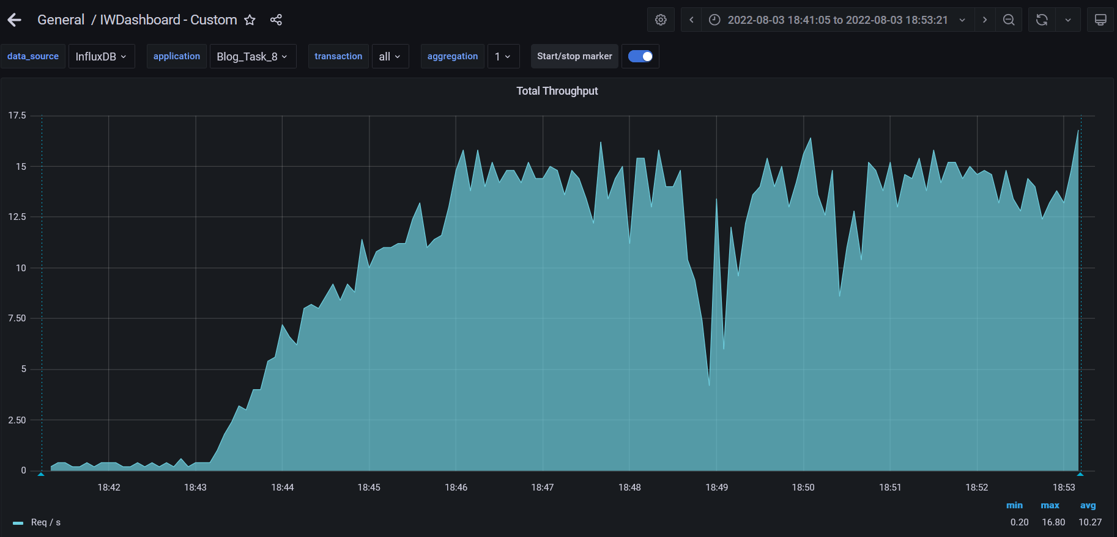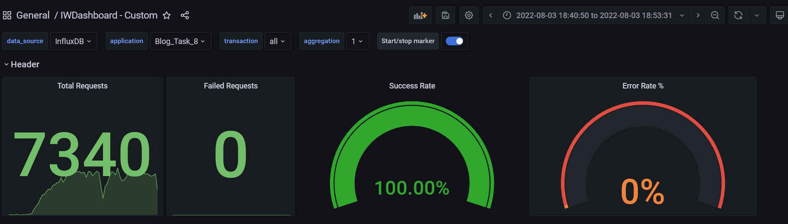

**Test Run #2 (Scale Model 1)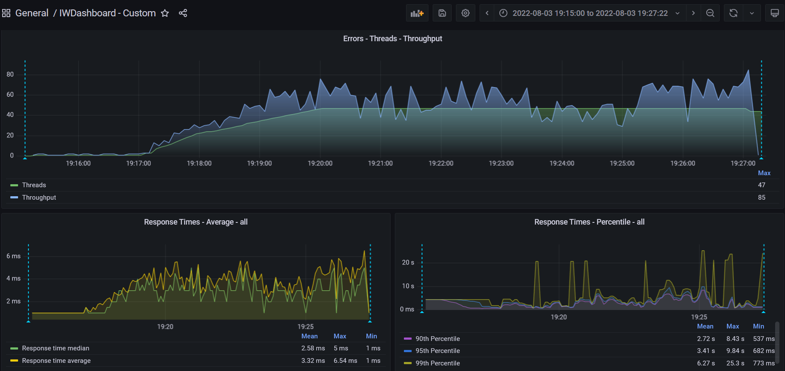**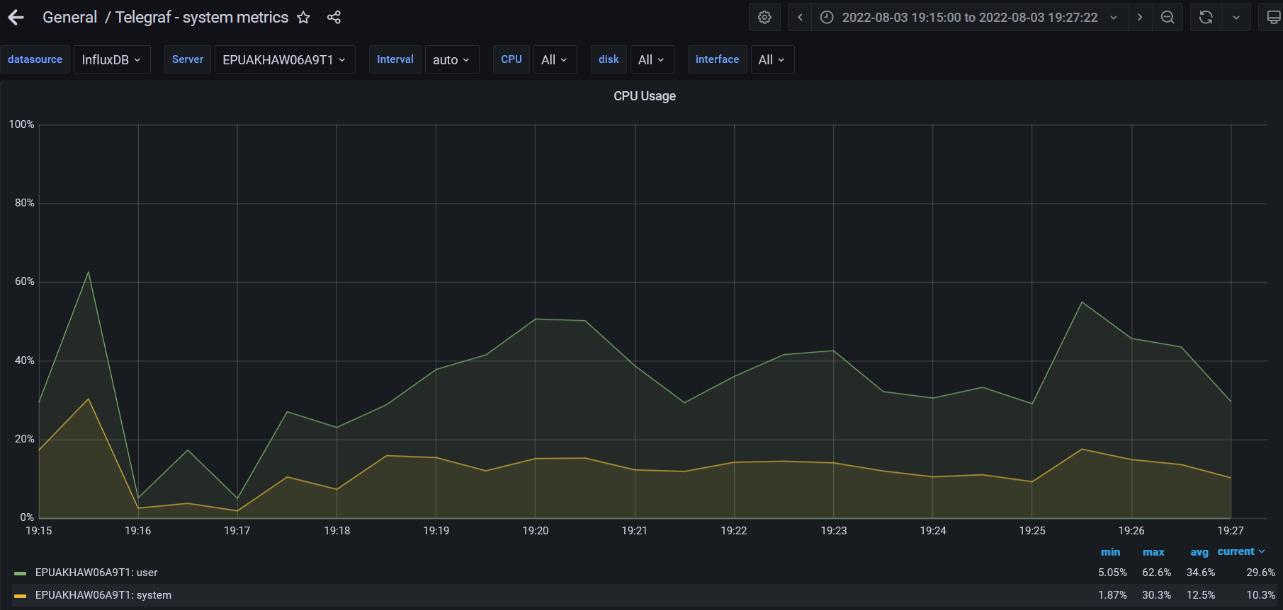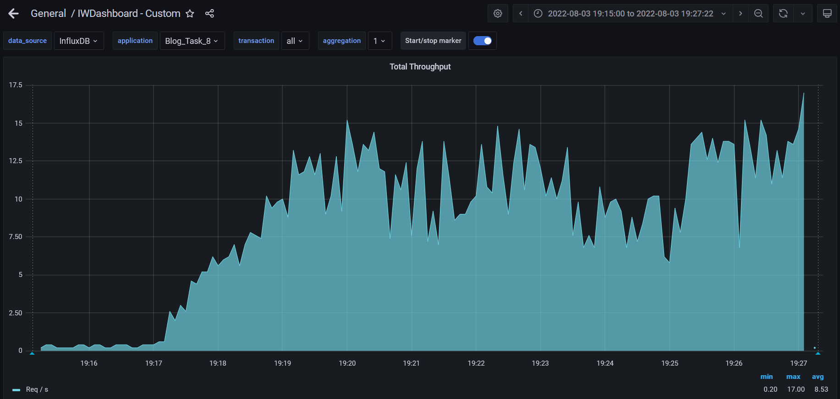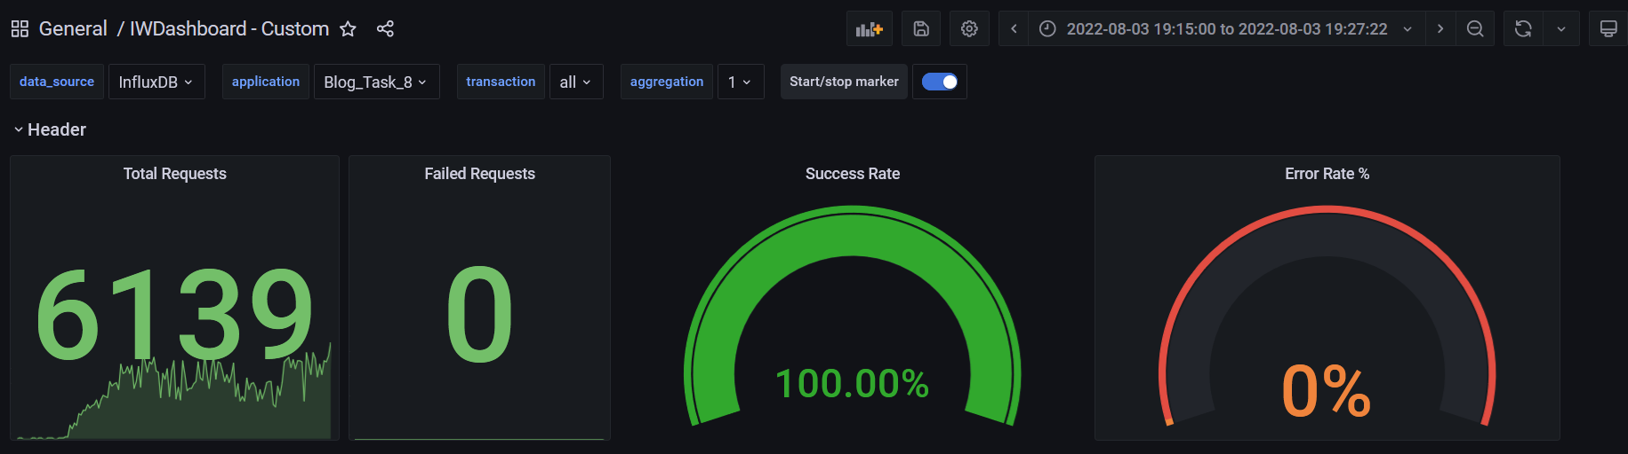

**Test Run #1 (Scale Model 2)**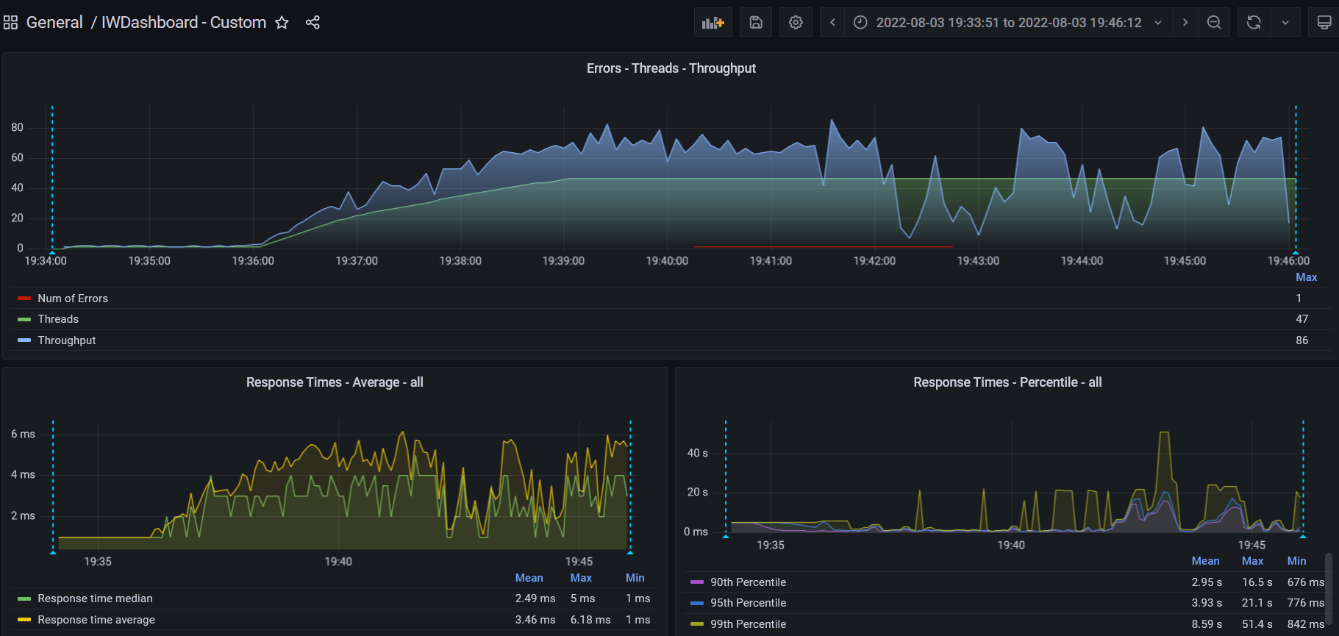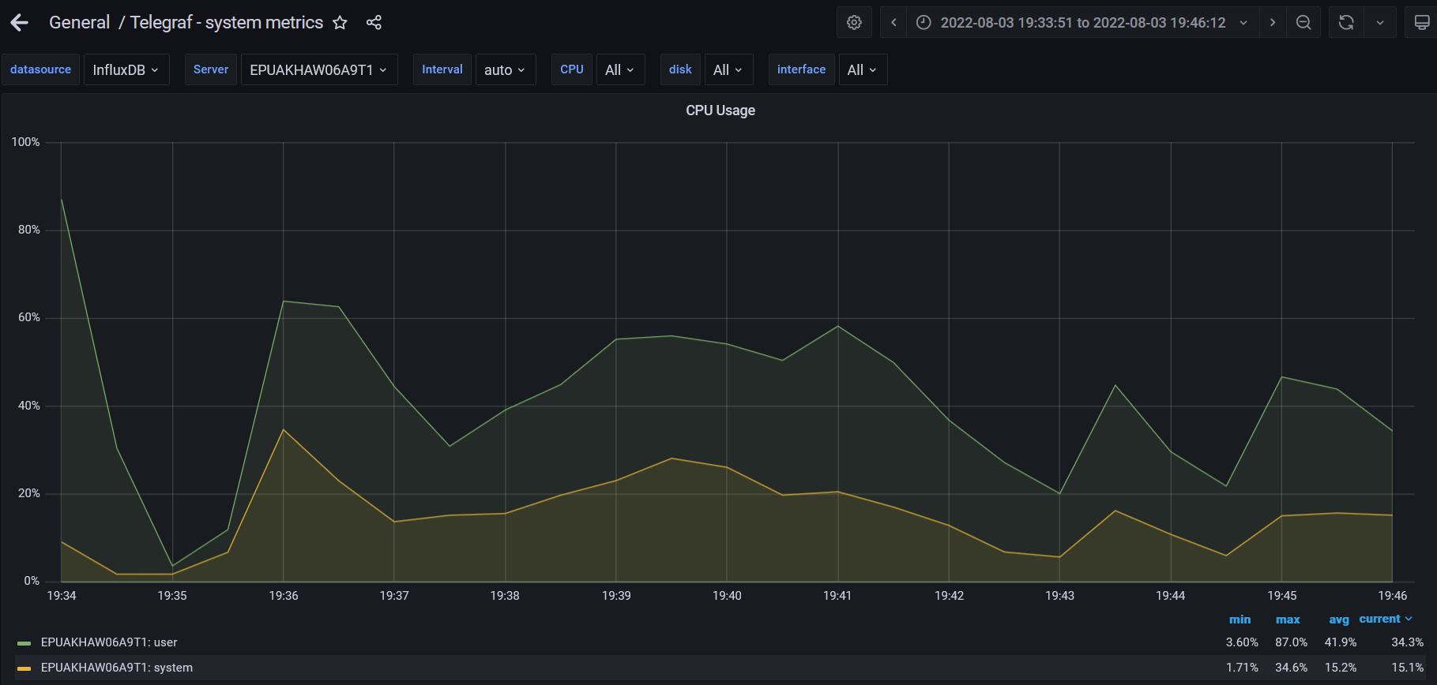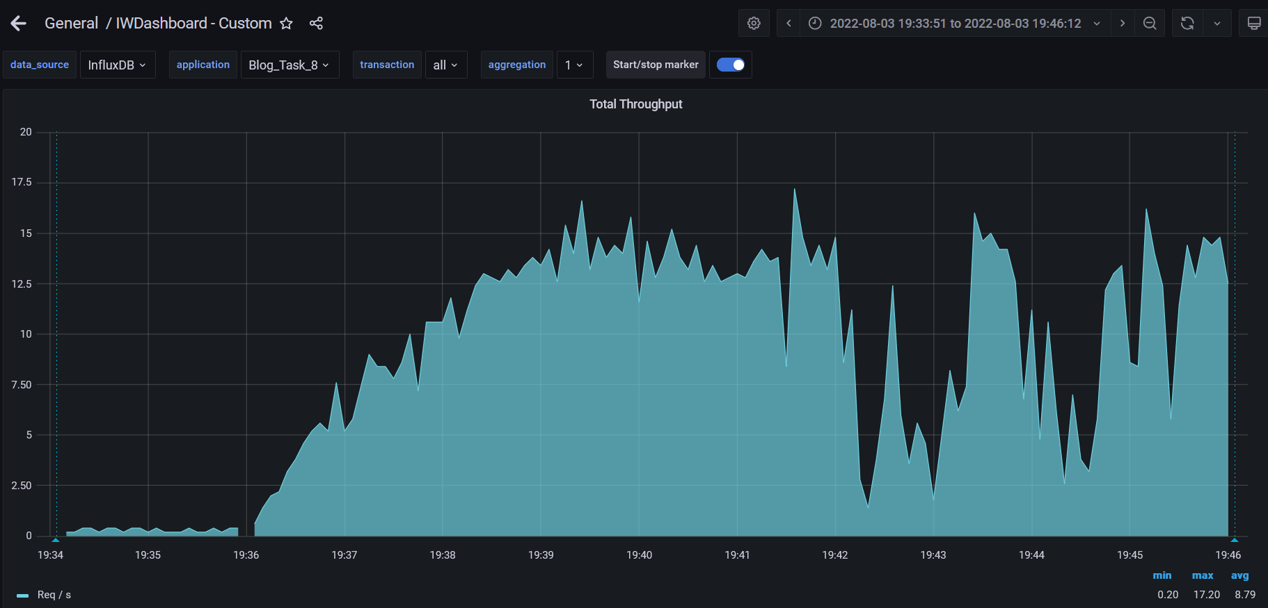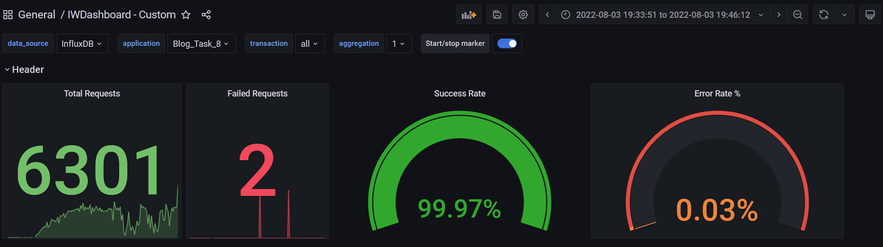

**Test Run #2 (Scale Model 2)**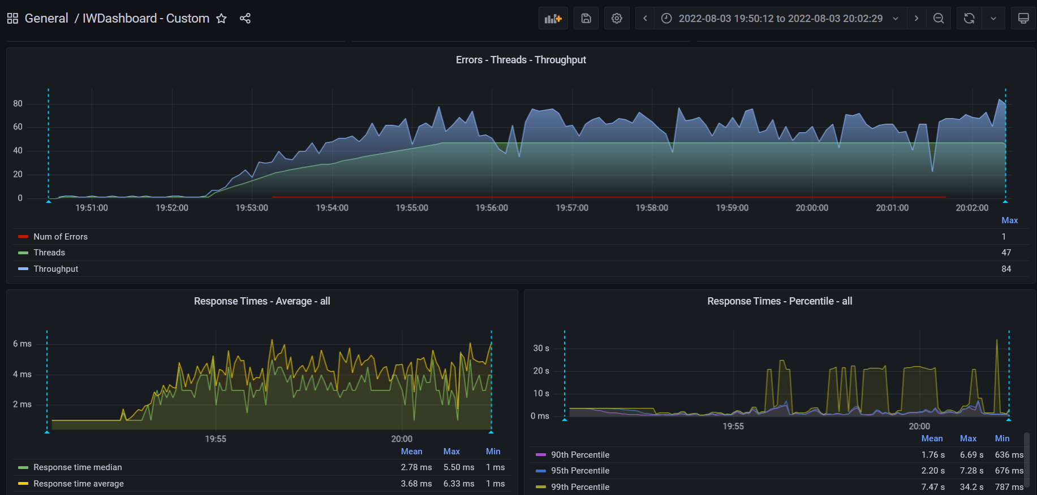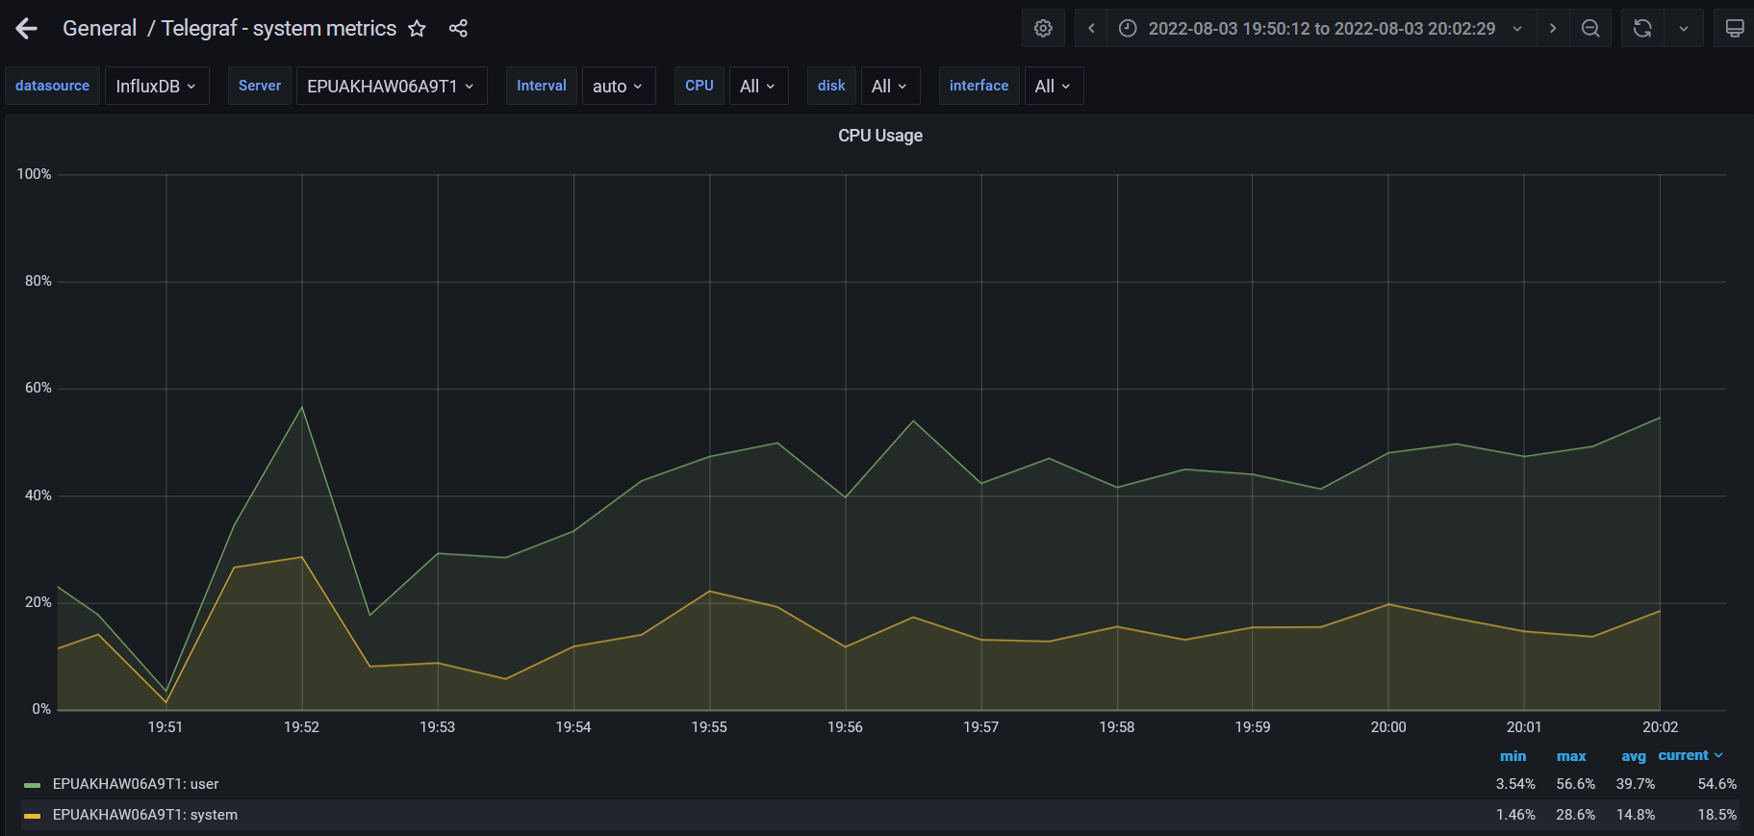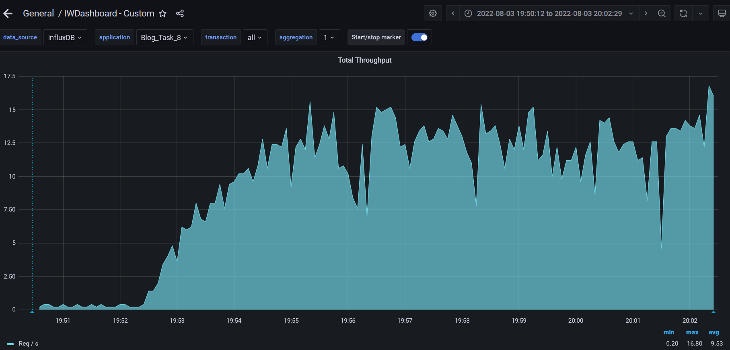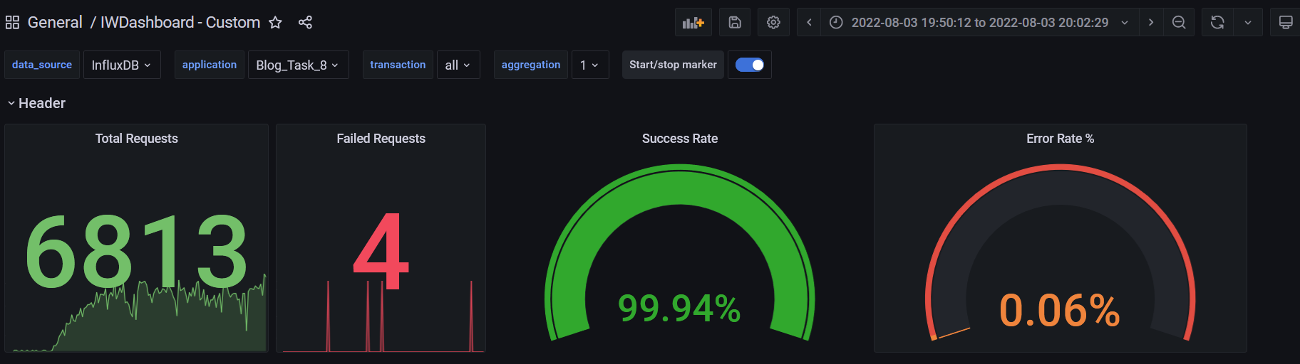

**Test Run #1 (Scale Model 3)**

**Detailed error report**

|  |  |  |
| --- | --- | --- |
| Response Code | Transaction | Error count |
| 500 | Transaction Controller (Open Home Page Anonymous)  Transaction Controller (Open PredefineDate)  Transaction Controller (Open Profile Page)  Transaction Controller (Open RandomDate)  Transaction Controller (Save Post)  Transaction Controller (Search By Name) | 1  2  1  1  17  4 |
| Non HTTP response code: java.net.SocketTimeoutException | Transaction Controller (Edit Post)  Transaction Controller (Login)  Transaction Controller (Open Contacts)  Transaction Controller (Open Date)  Transaction Controller (Open Home Page Anonymous)  Transaction Controller (Open Home Page)  Transaction Controller (Open Large Calendar)  Transaction Controller (Open Post)  Transaction Controller (Open PredefineDate)  Transaction Controller (Open Profile Page)  Transaction Controller (Open RandomDate)  Transaction Controller (Open User Page)  Transaction Controller (Save Post)  Transaction Controller (Search By Name) | 4  1  2  2  11  2  4  5  16  1  8  1  1  20 |
| Non HTTP response code: java.net.URISyntaxException | Transaction Controller (Edit Post) | 5 |

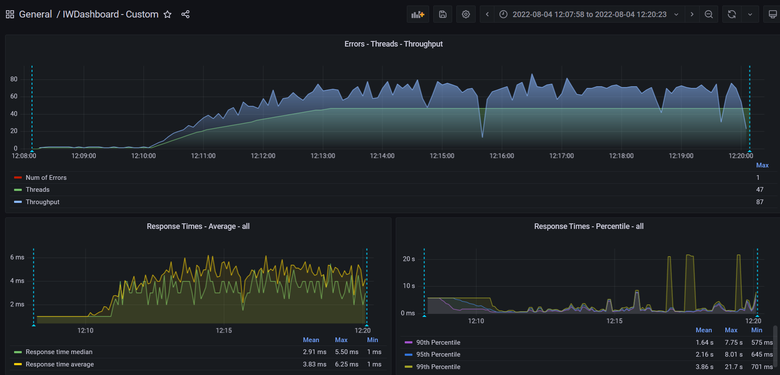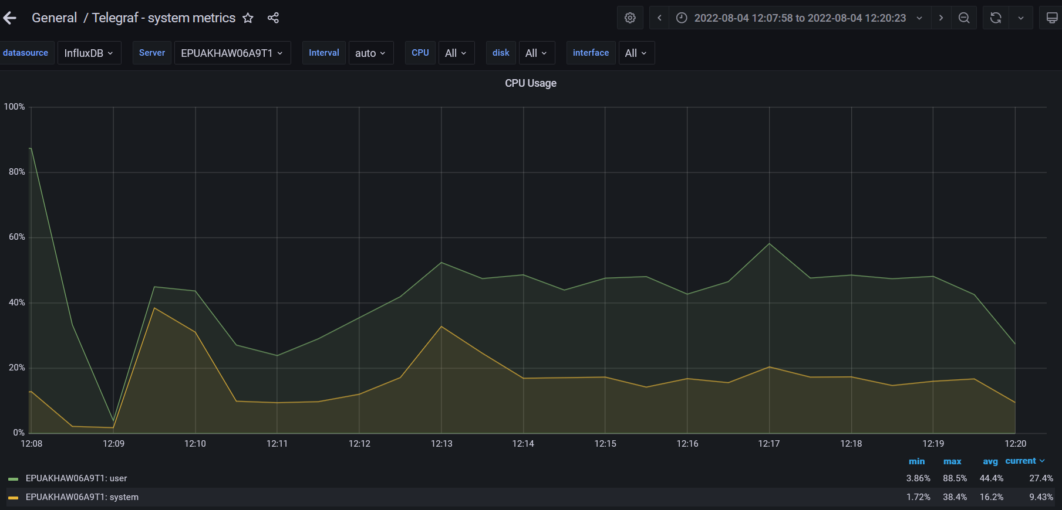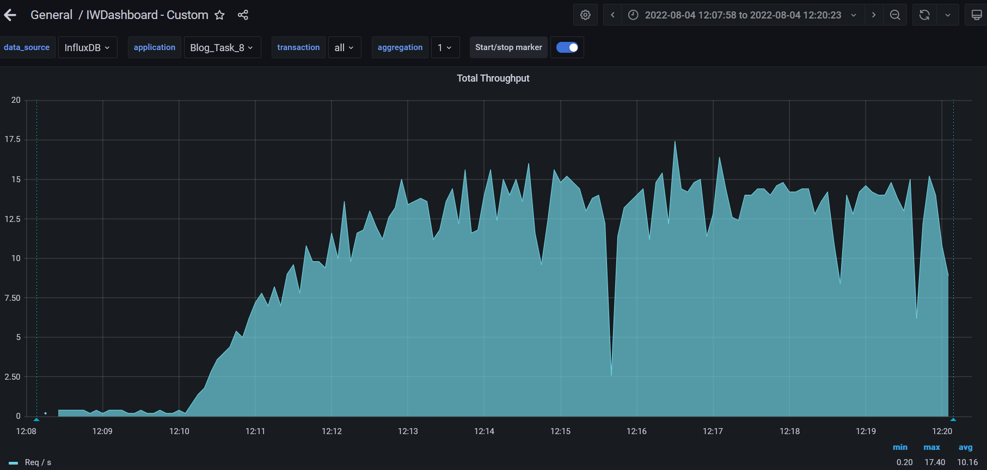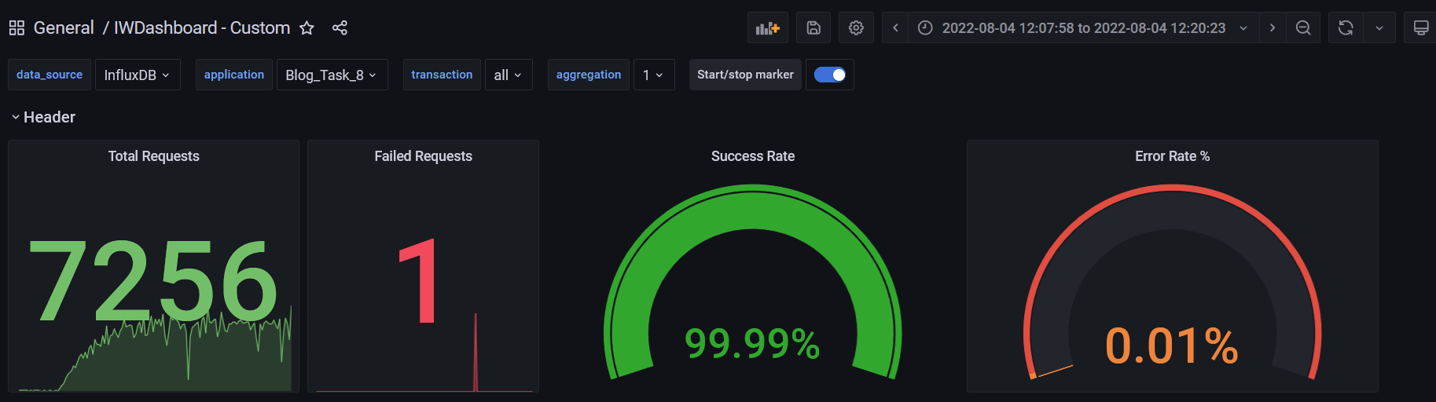

**Test Run #2 (Scale Model 3)**

**Detailed error report**

|  |  |  |
| --- | --- | --- |
| Response Code | Transaction | Error count |
| 500 | Transaction Controller (Open PredefineDate)  Transaction Controller (Save Post) | 1  10 |
| Non HTTP response code: java.net.SocketTimeoutException | Transaction Controller (Add User)  Transaction Controller (Edit Post)  Transaction Controller (Open Contacts)  Transaction Controller (Open Date)  Transaction Controller (Open Home Page Anonymous)  Transaction Controller (Open Home Page)  Transaction Controller (Open Large Calendar)  Transaction Controller (Open Post)  Transaction Controller (Open PredefineDate)  Transaction Controller (Open Profile Page)  Transaction Controller (Open RandomDate)  Transaction Controller (Open User Page)  Transaction Controller (Save Post)  Transaction Controller (Search By Name) | 1  3  5  2  7  2  4  5  18  1  8  2  2  19 |
| Non HTTP response code: java.net.URISyntaxException | Transaction Controller (Edit Post) | 5 |

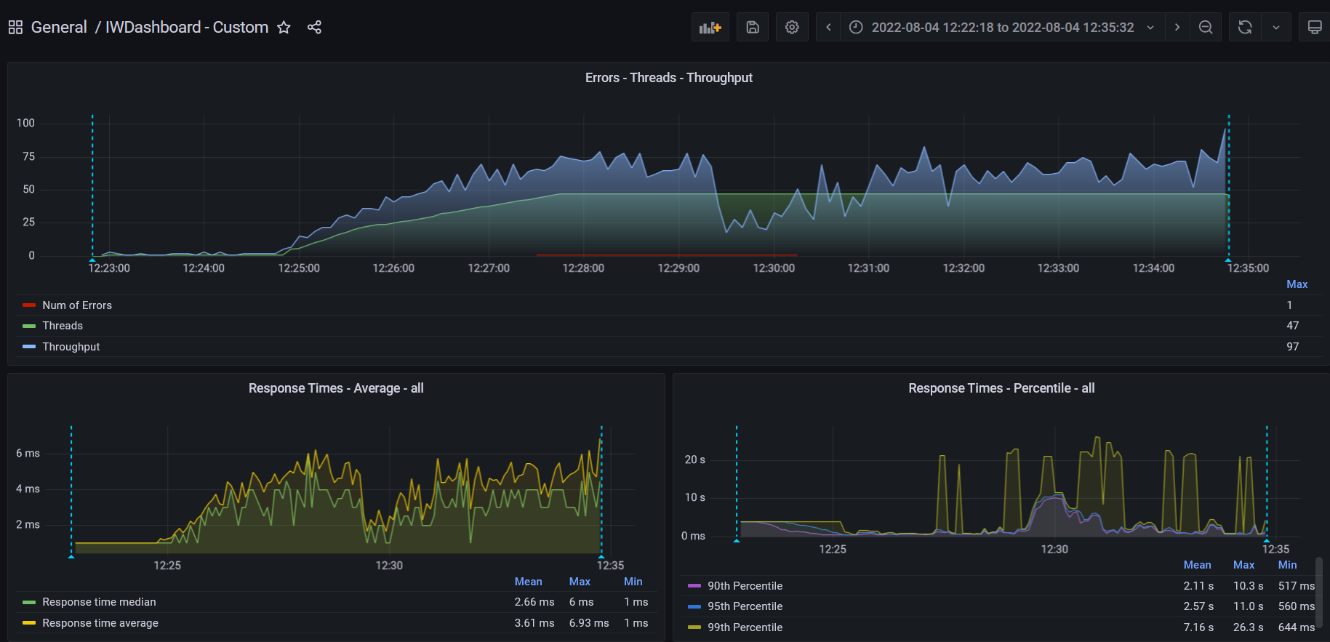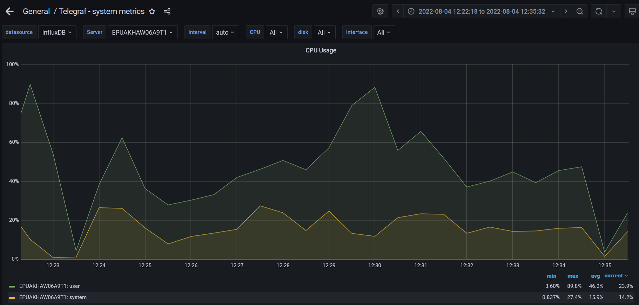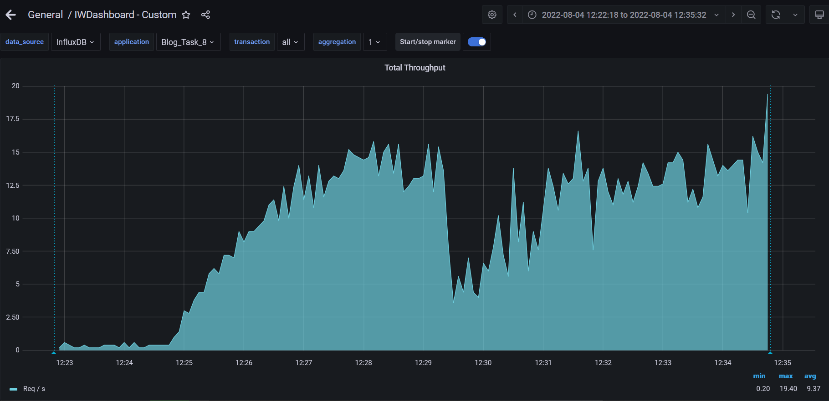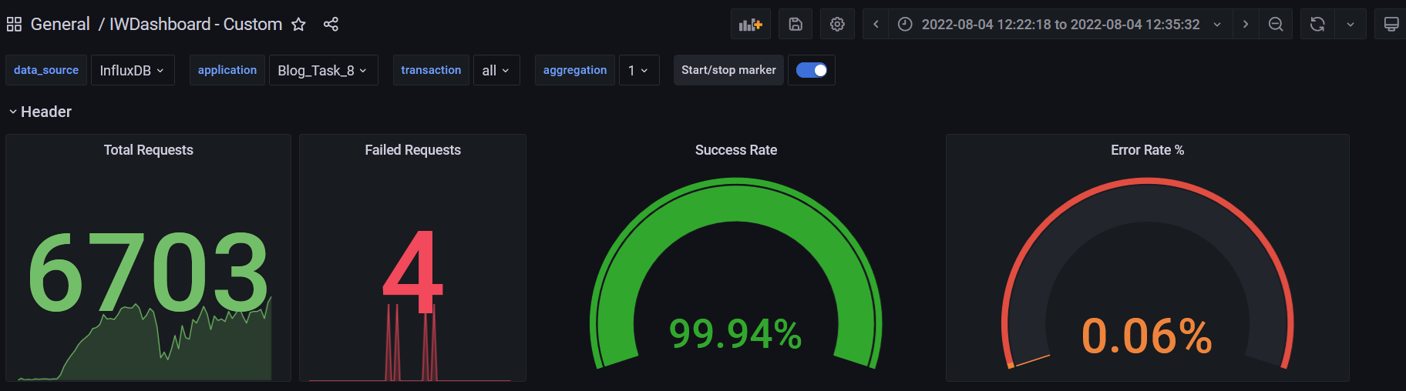

**Test Run #1 (Scale Model 4)**

**Detailed error report**

|  |  |  |
| --- | --- | --- |
| Response Code | Transaction | Error count |
| 500 | Transaction Controller (Open PredefineDate)  Transaction Controller (Save Post) | 1  10 |
| Non HTTP response code: java.net.SocketTimeoutException | Transaction Controller (Edit Post)  Transaction Controller (Open Date)  Transaction Controller (Open Large Calendar)  Transaction Controller (Open PredefineDate)  Transaction Controller (Open RandomDate)  Transaction Controller (Save Post)  Transaction Controller (Search By Name) | 2  1  1  9  2  31  2 |
| Non HTTP response code: java.net.URISyntaxException | Transaction Controller (Edit Post) | 3 |

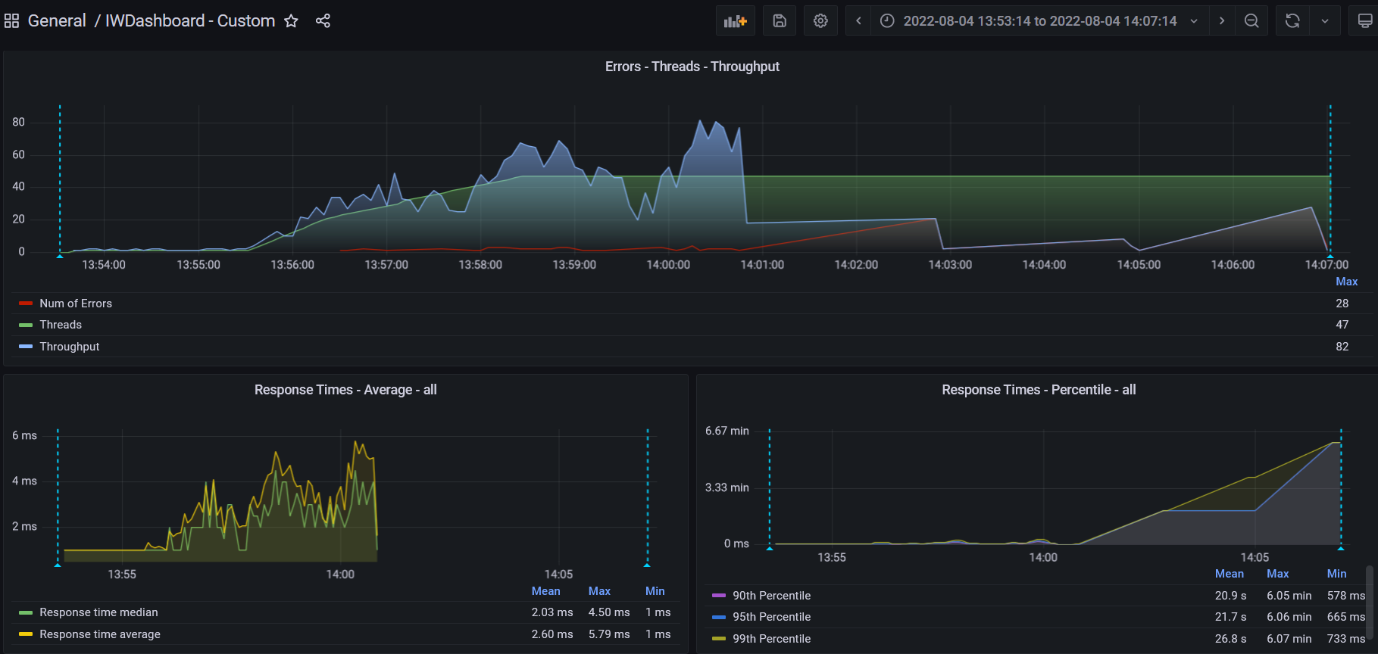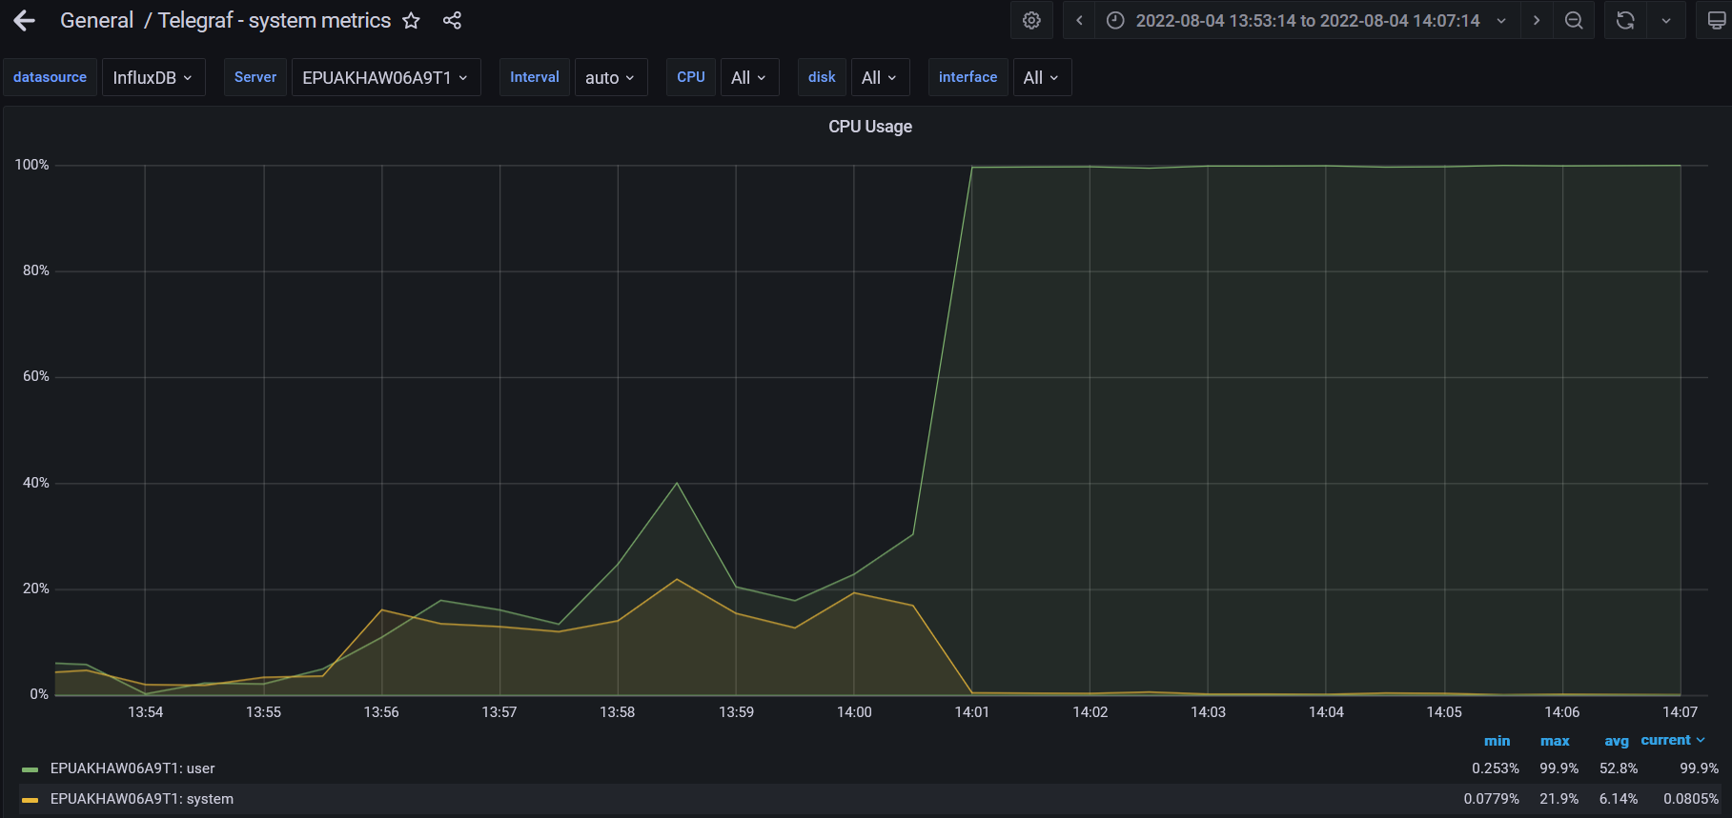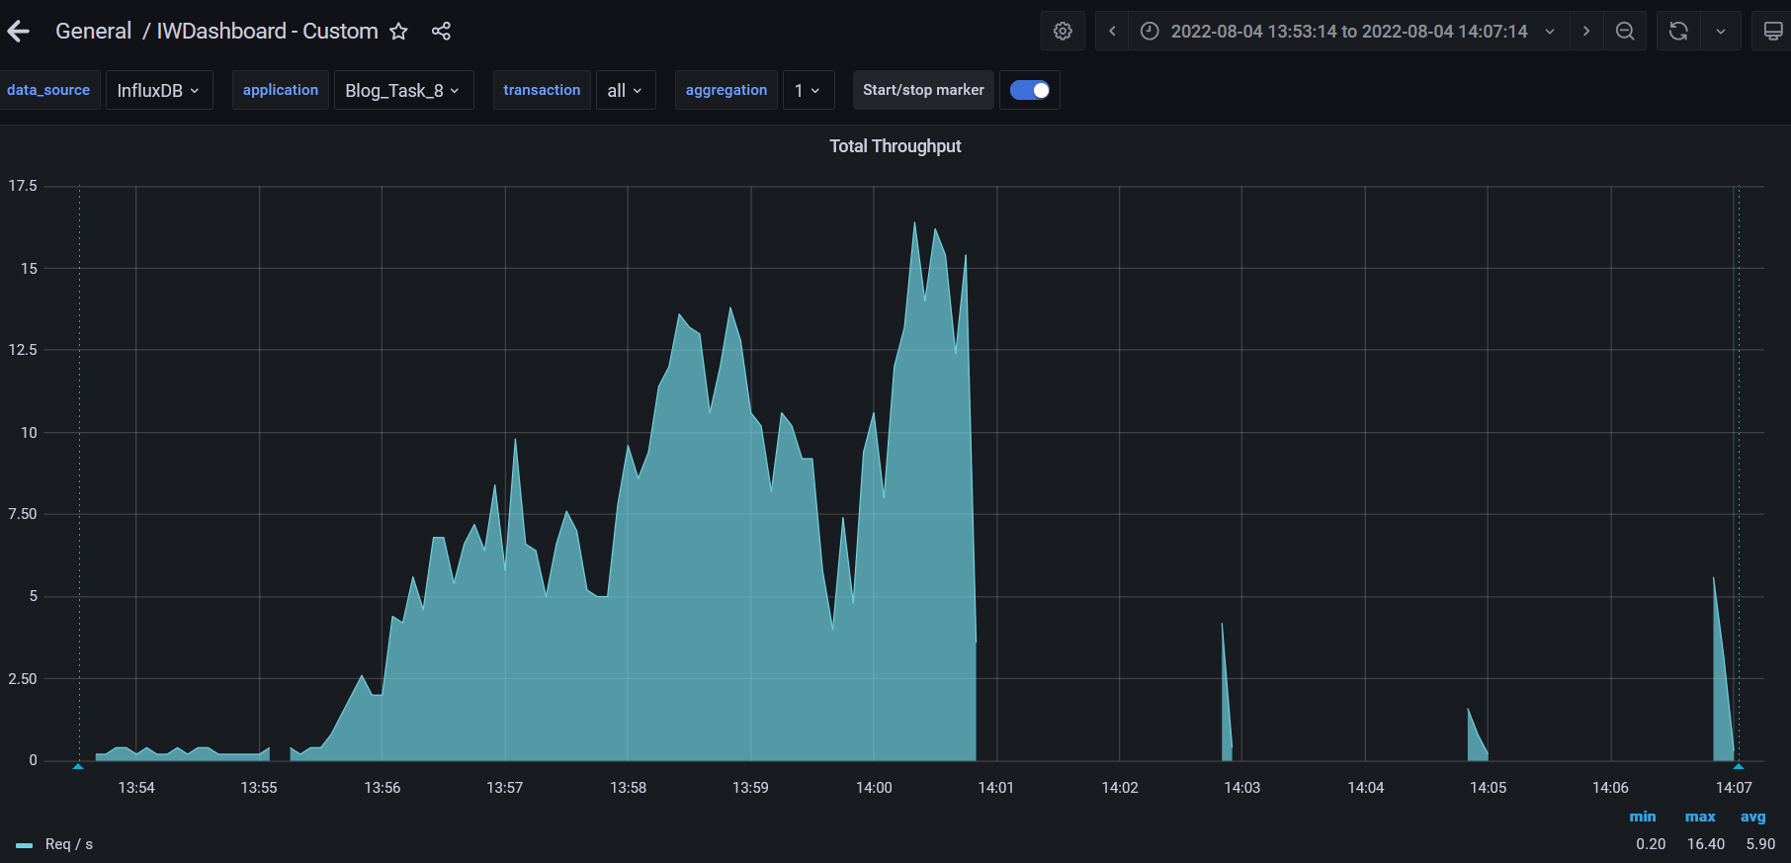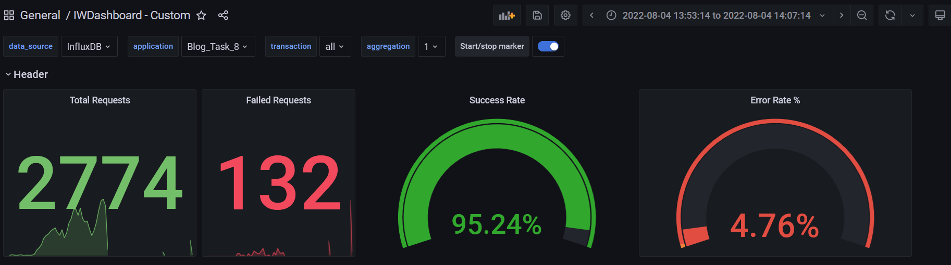

**Test Run #2 (Scale Model 4)**

**Detailed error report**

|  |  |  |
| --- | --- | --- |
| Response Code | Transaction | Error count |
| 500 | Transaction Controller (Open PredefineDate)  Transaction Controller (Save Post) | 1  10 |
| Non HTTP response code: java.net.SocketTimeoutException | Transaction Controller (Open Home Page Anonymous)  Transaction Controller (Open Large Calendar)  Transaction Controller (Open PredefineDate)  Transaction Controller (Open RandomDate)  Transaction Controller (Save Post)  Transaction Controller (Search By Name) | 1  2  2  2  16  2 |
| Non HTTP response code: java.net.URISyntaxException | Transaction Controller (Edit Post) | 7 |

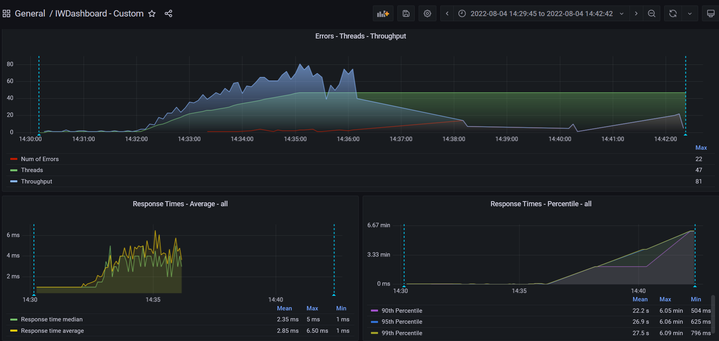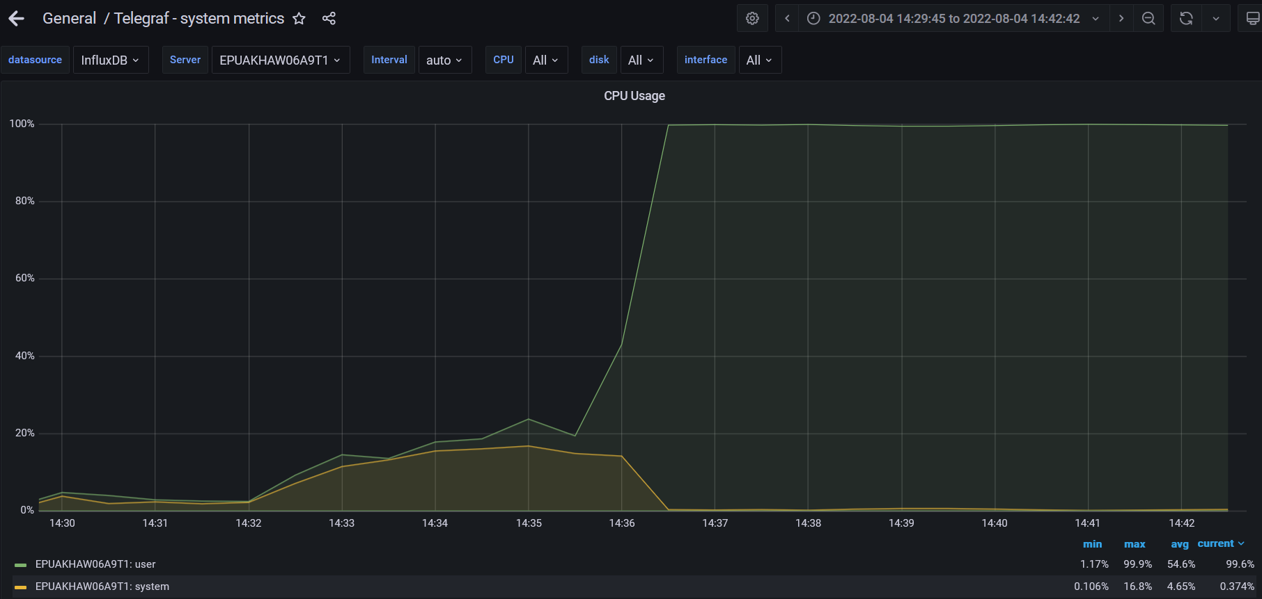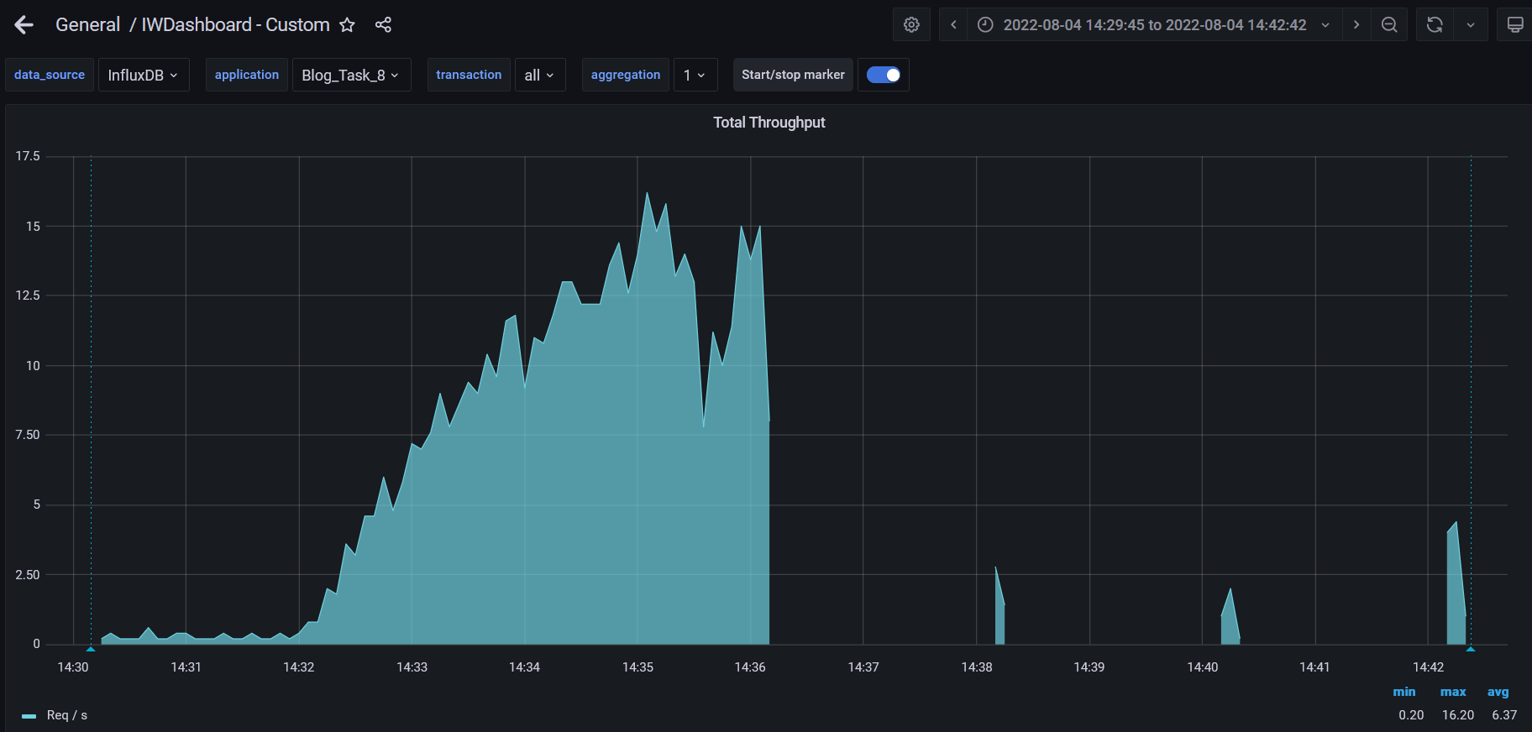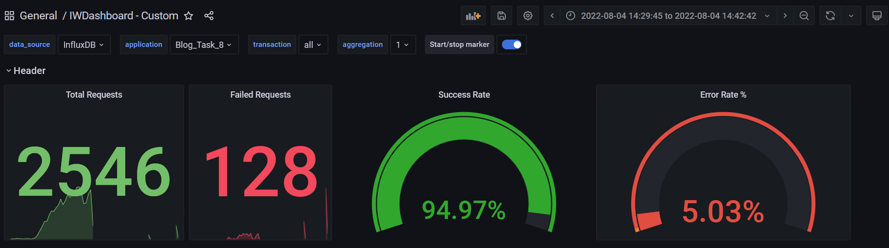

**Test Run #1 (Scale Model 5)**

**Detailed error report**

|  |  |  |
| --- | --- | --- |
| Response Code | Transaction | Error count |
| 500 | Transaction Controller (Edit Post)  Transaction Controller (Open Date)  Transaction Controller (Open Large Calendar)  Transaction Controller (Open PredefineDate)  Transaction Controller (Open RandomDate)  Transaction Controller (Save Post)  Transaction Controller (Search By Name) | 2  1  1  9  2  31  2 |
| Non HTTP response code: java.net.SocketTimeoutException | Transaction Controller (Edit Post)  Transaction Controller (Open Contacts)  Transaction Controller (Open Date)  Transaction Controller (Open Home Page Anonymous)  Transaction Controller (Open Home Page)  Transaction Controller (Open Large Calendar)  Transaction Controller (Open Post)  Transaction Controller (Open PredefineDate)  Transaction Controller (Open RandomDate)  Transaction Controller (Open User Page)  Transaction Controller (Save Post)  Transaction Controller (Search By Name) | 1  3  5  9  1  2  7  15  6  1  2  18 |
| Non HTTP response code: java.net.URISyntaxException | Transaction Controller (Edit Post) | 3 |

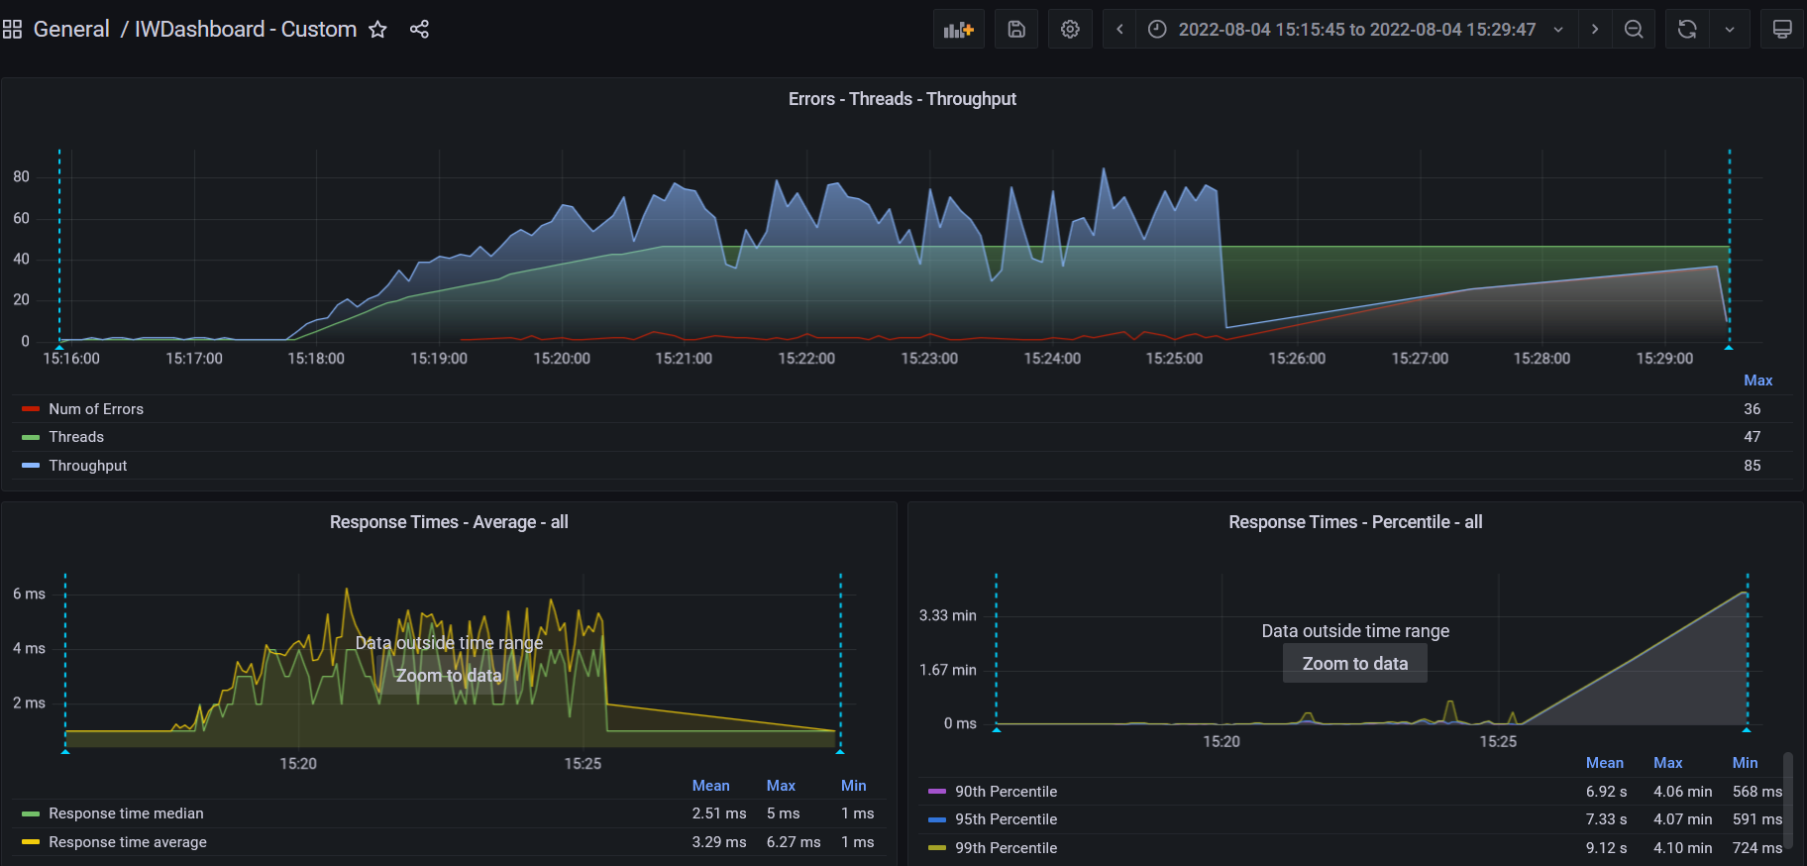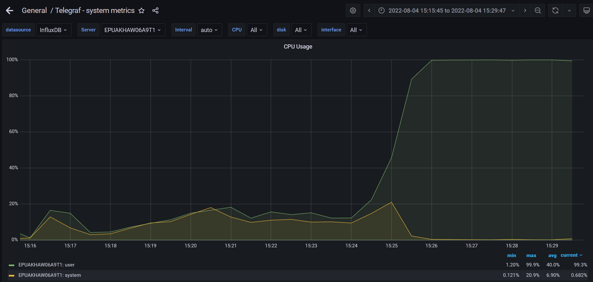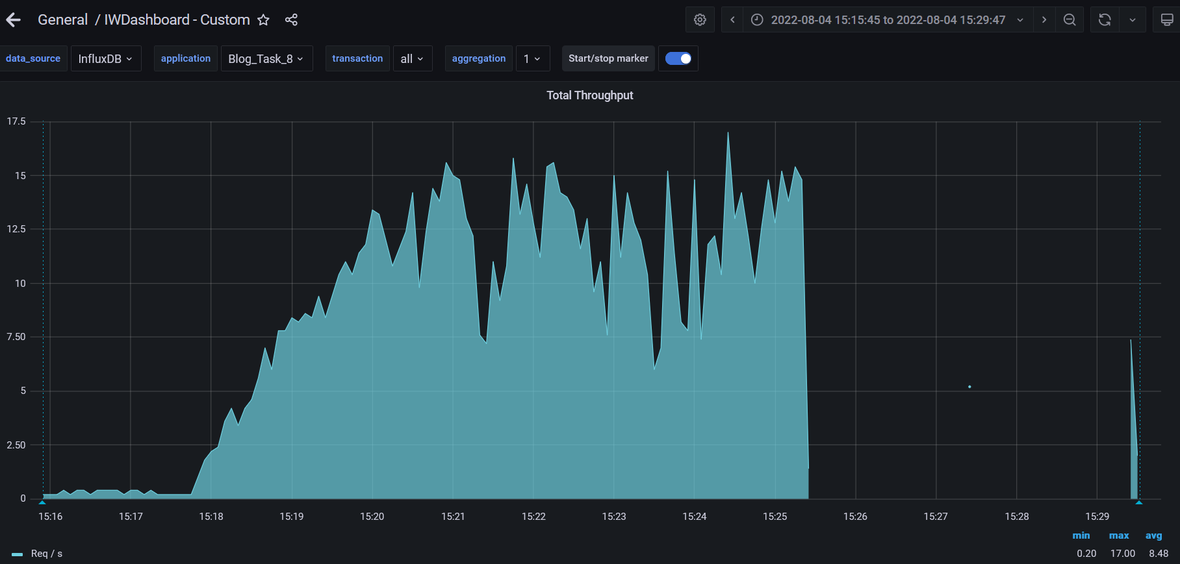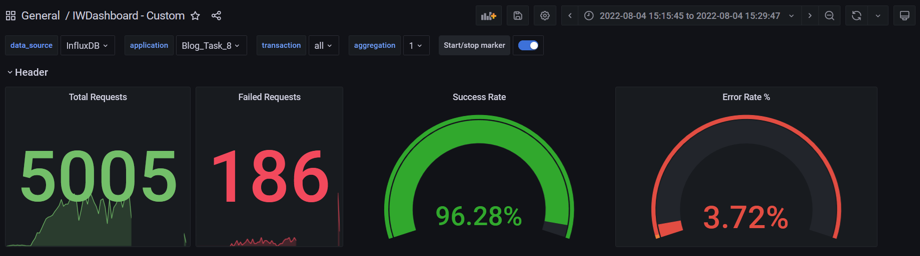

**Test Run #2 (Scale Model 5)**

**Detailed error report**

|  |  |  |
| --- | --- | --- |
| Response Code | Transaction | Error count |
| 500 | Transaction Controller (Open Home Page Anonymous)  Transaction Controller (Open Large Calendar)  Transaction Controller (Open PredefineDate)  Transaction Controller (Open RandomDate)  Transaction Controller (Save Post)  Transaction Controller (Search By Name) | 1  2  2  2  16  2 |
| Non HTTP response code: java.net.SocketTimeoutException | Transaction Controller (Edit Post)  Transaction Controller (Open Admin Page)  Transaction Controller (Open Contacts)  Transaction Controller (Open Date)  Transaction Controller (Open Home Page Anonymous)  Transaction Controller (Open Large Calendar)  Transaction Controller (Open Post)  Transaction Controller (Open PredefineDate)  Transaction Controller (Open Profile Page)  Transaction Controller (Open RandomDate)  Transaction Controller (Open User Page)  Transaction Controller (Save Post)  Transaction Controller (Search By Name) | 2  1  3  2  9  1  6  20  2  9  1  2  19 |
| Non HTTP response code: java.net.URISyntaxException | Transaction Controller (Edit Post) | 7 |

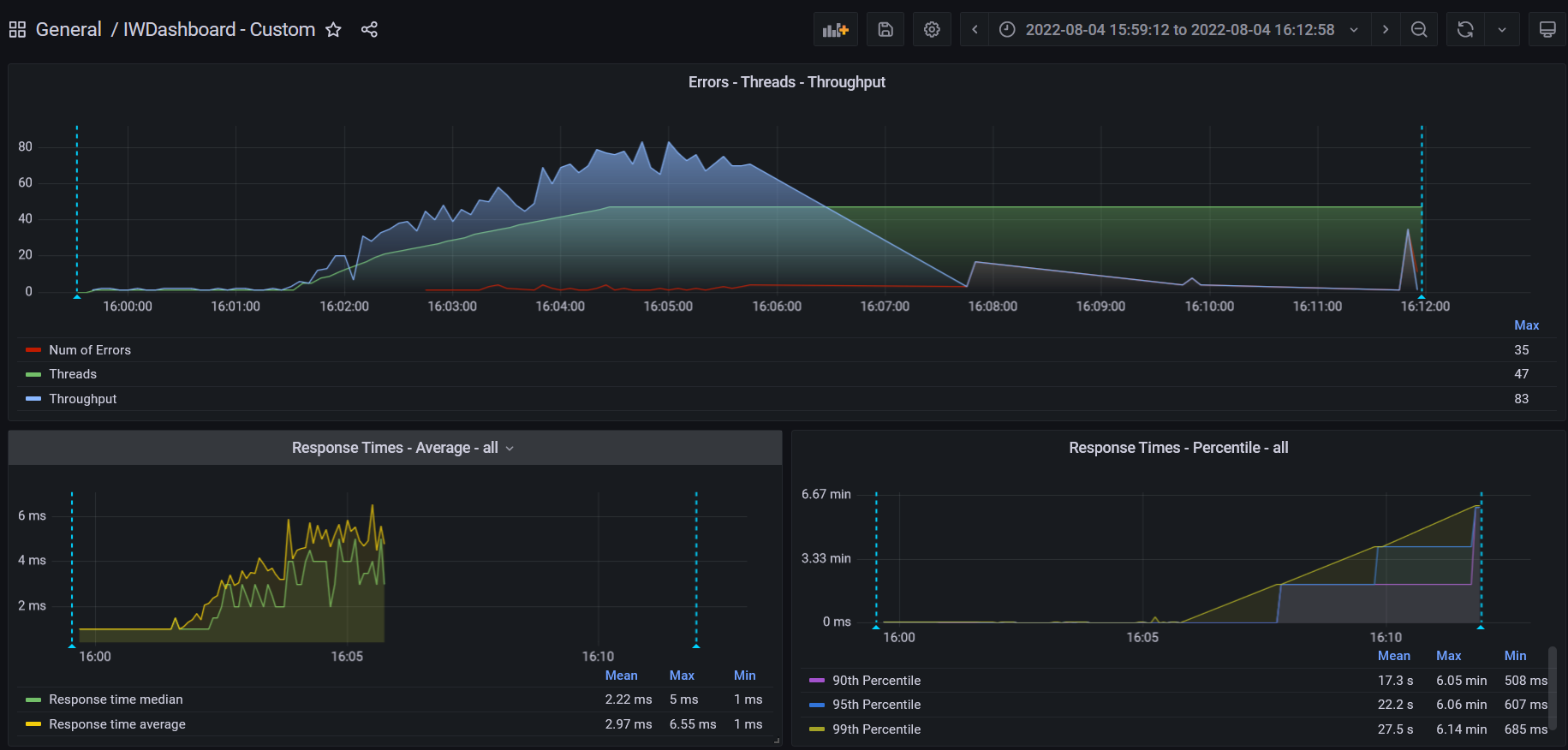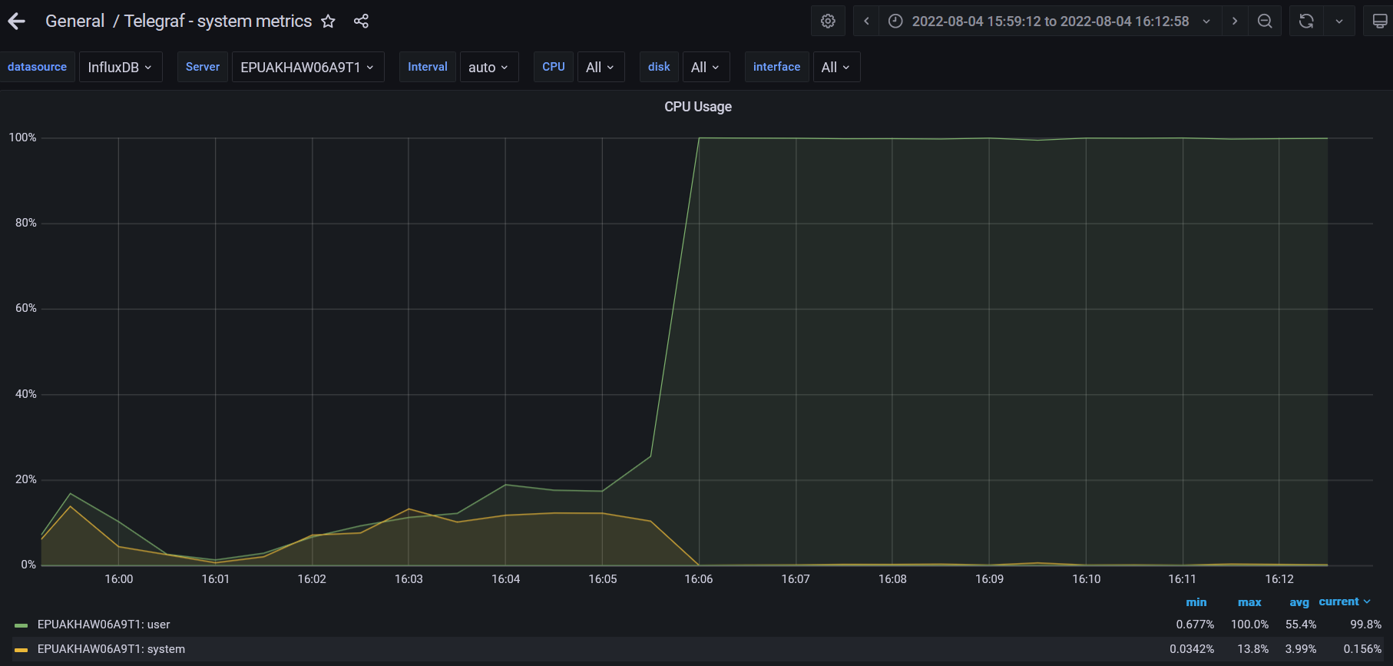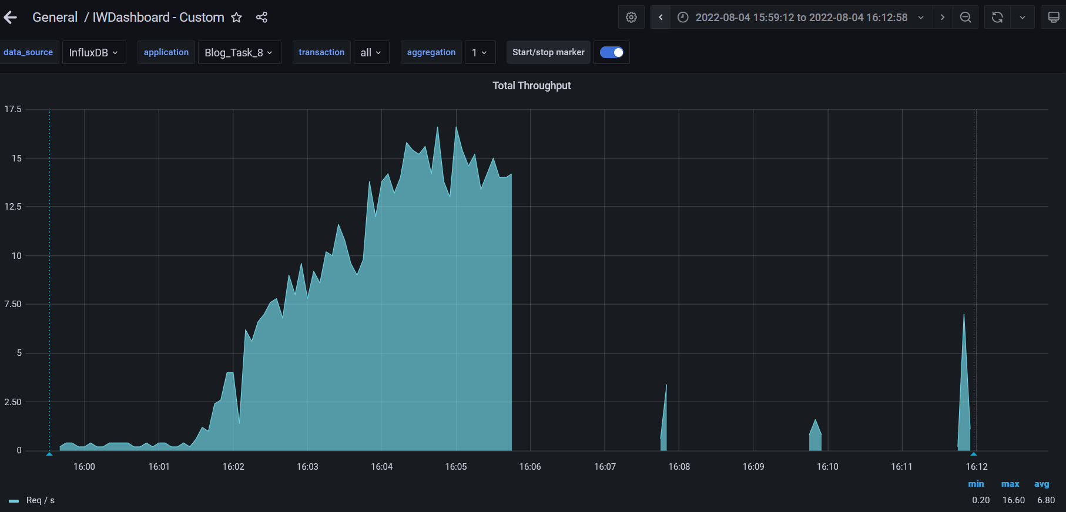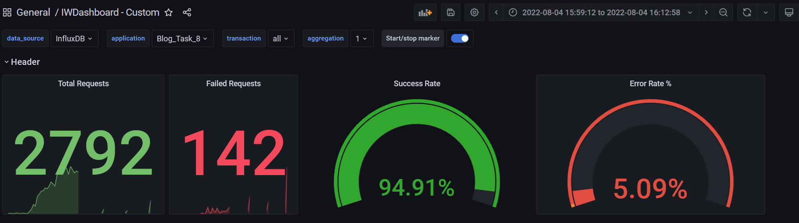

**Test Run #1 (Scale Model 6)**

**Detailed error report**

|  |  |  |
| --- | --- | --- |
| Response Code | Transaction | Error count |
| 500 | Transaction Controller (Open Date)  Transaction Controller (Open Home Page Anonymous)  Transaction Controller (Open Post)  Transaction Controller (Open PredefineDate)  Transaction Controller (Save Post)  Transaction Controller (Search By Name) | 1  1  1  1  21  2 |
| Non HTTP response code: java.net.SocketTimeoutException | Transaction Controller (Edit Post)  Transaction Controller (Open Admin Page)  Transaction Controller (Open Date)  Transaction Controller (Open Home Page Anonymous)  Transaction Controller (Open Large Calendar)  Transaction Controller (Open Post)  Transaction Controller (Open PredefineDate)  Transaction Controller (Open RandomDate)  Transaction Controller (Save Post)  Transaction Controller (Search By Name) | 3  2  2  10  3  5  17  3  2  21 |
| Non HTTP response code: java.net.URISyntaxException | Transaction Controller (Edit Post) | 5 |

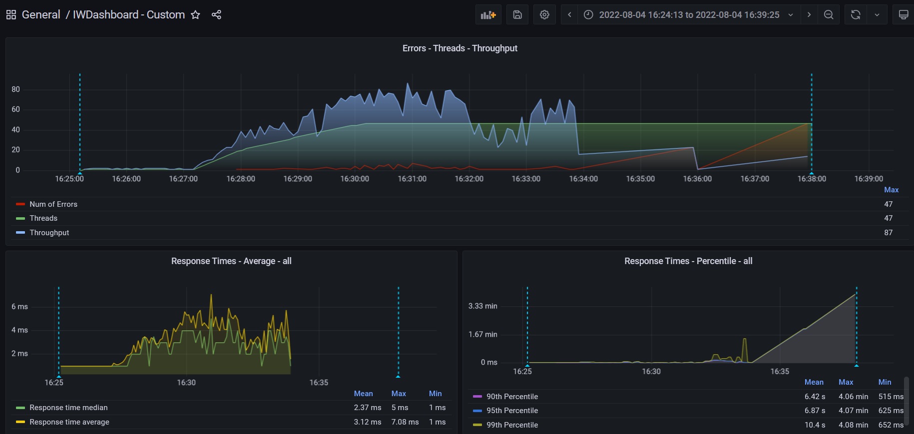

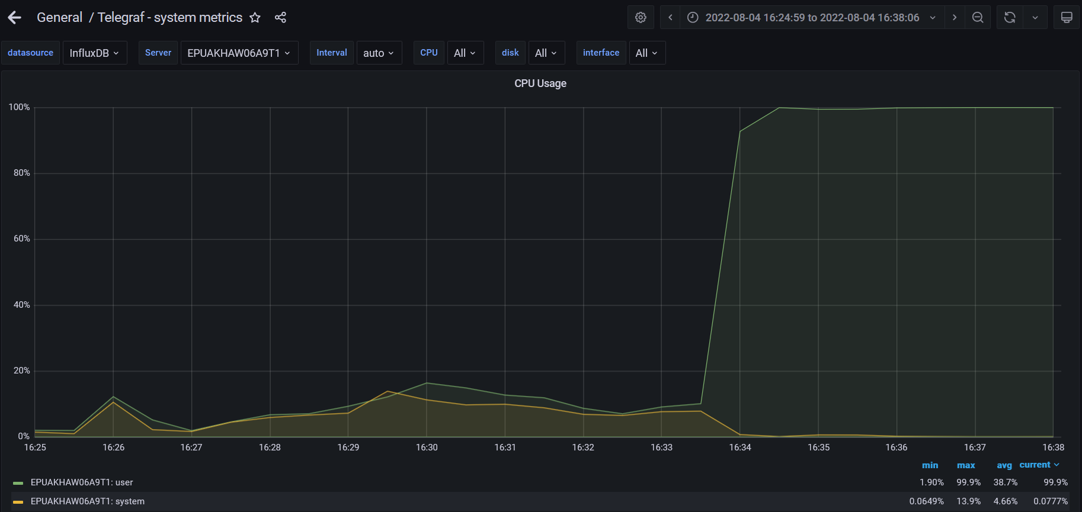

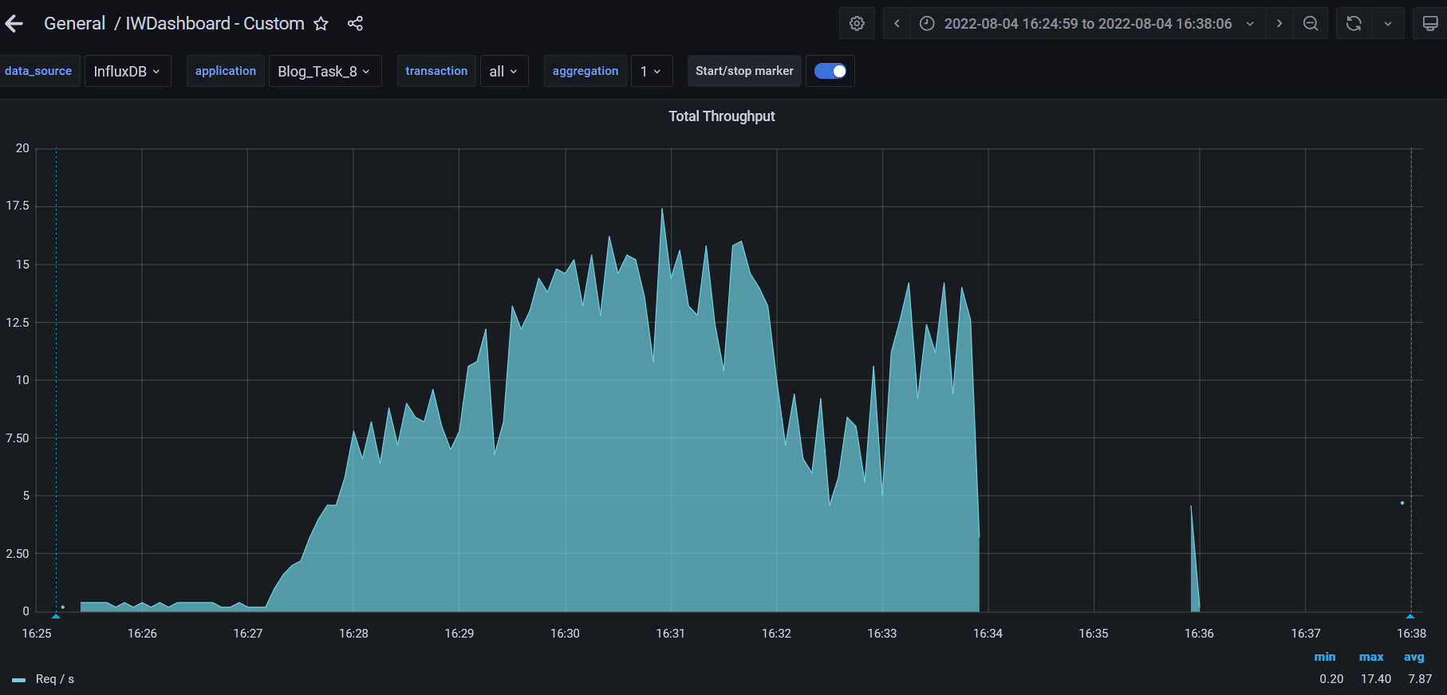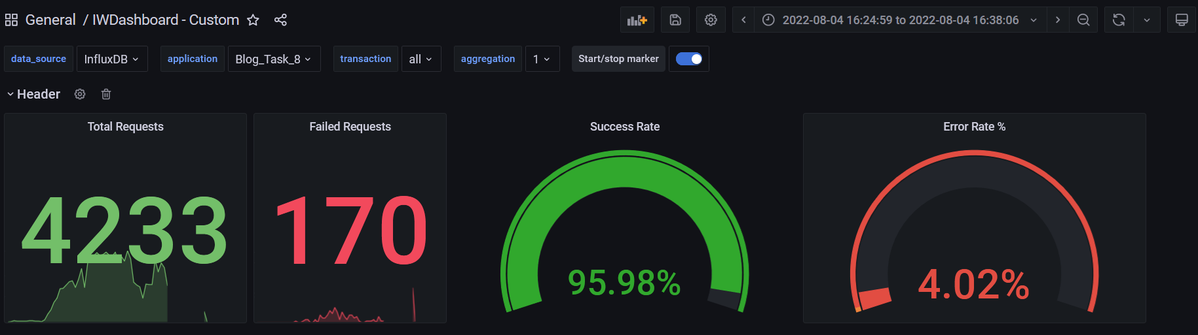

**Test Run #2 (Scale Model 6)**

**Detailed error report**

|  |  |  |
| --- | --- | --- |
| Response Code | Transaction | Error count |
| 500 | Transaction Controller (Edit Post)  Transaction Controller (Open Contacts)  Transaction Controller (Open Date)  Transaction Controller (Open Home Page Anonymous)  Transaction Controller (Open Large Calendar)  Transaction Controller (Open Post)  Transaction Controller (Open PredefineDate)  Transaction Controller (Open RandomDate)  Transaction Controller (Save Post)  Transaction Controller (Search By Name) | 1  1  3  3  4  1  8  3  67  2 |
| Non HTTP response code: java.net.SocketTimeoutException | Transaction Controller (Edit Post)  Transaction Controller (Open Admin Page)  Transaction Controller (Open Contacts)  Transaction Controller (Open Date)  Transaction Controller (Open Home Page Anonymous)  Transaction Controller (Open Large Calendar)  Transaction Controller (Open Post)  Transaction Controller (Open PredefineDate)  Transaction Controller (Open RandomDate)  Transaction Controller (Open User Page)  Transaction Controller (Save Post)  Transaction Controller (Search By Name) | 4  1  2  1  4  3  4  10  4  1  1  12 |
| Non HTTP response code: java.net.URISyntaxException | Transaction Controller (Edit Post) | 4 |

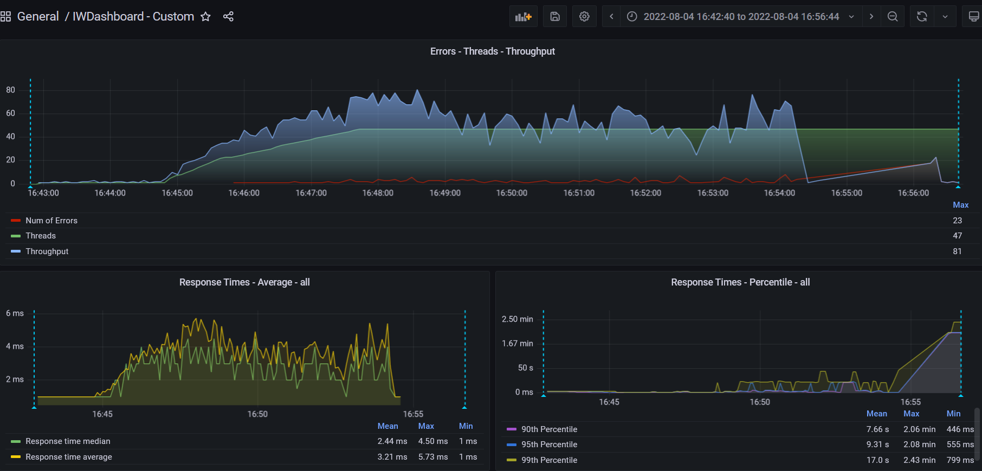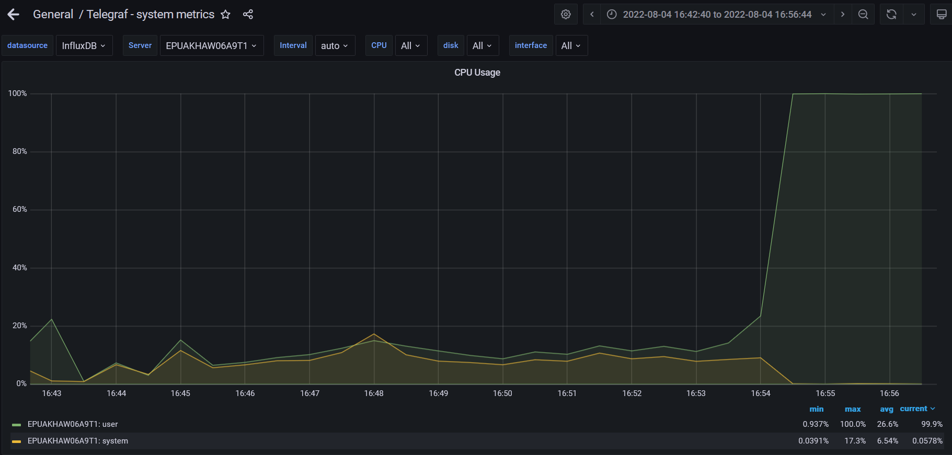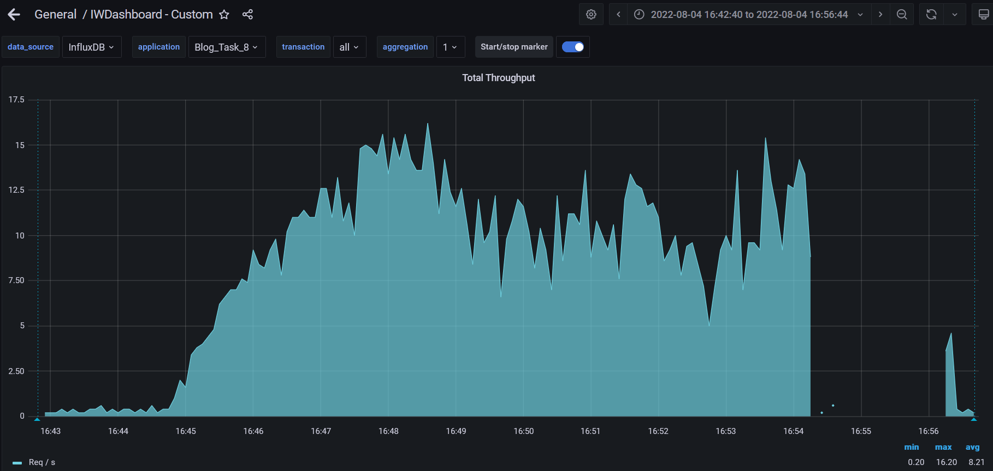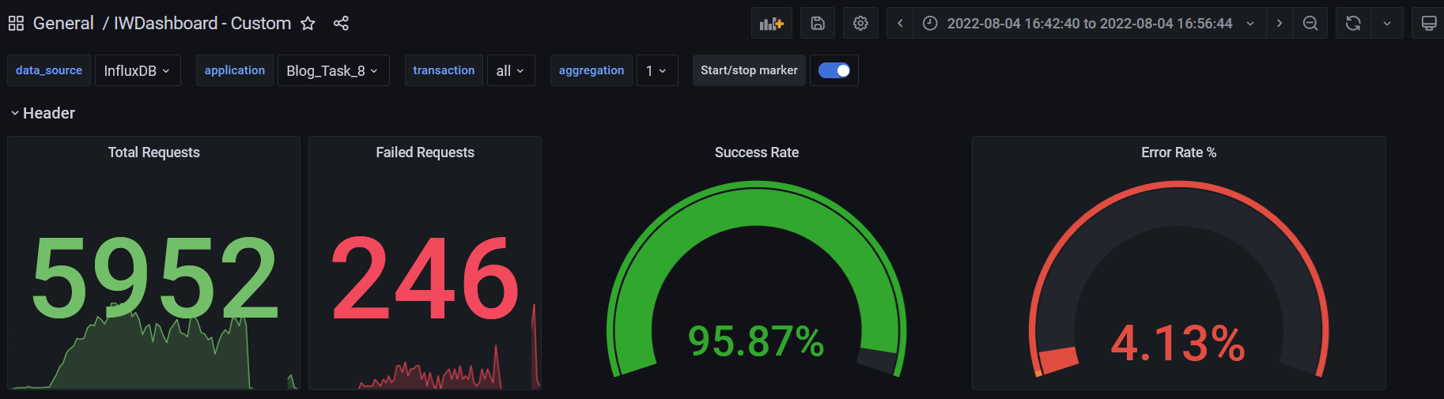

1. **Conclusion:**

The server worked stable according to the received test results by 3 runs for 1 CPU. The best result was defined for using the app on 1 CPU were work stable on RAM by 8,12,16 GB, next 6 runs with using params with 2,3,4 CPUs with and CPUs param 8,12,16 GB was unstable, error county was approximately 150-200 error by every run, the user's request is falling after reaching server timeout and CPUs is growing to 100%. The main parameters for marks are Total Errors, Num Max Throughput, Response time average. The appropriate params for server work are 1 CPU and 4GB of RAM.

**General Key Performance Indicators (KPI) from Task 8**

|  |  |  |  |  |  |  |  |  |
| --- | --- | --- | --- | --- | --- | --- | --- | --- |
|  | **CPU** | **RAM** | **Throughput (Max)** | **Errors (Total)** | **Response time (Average)** | **Response time (Median)** | **90th Percentile (Mean)** | **95th Percentile (Mean)** |
| Load model (Task 8) | 1 Core | 8 GB | 16.80 Req/s | 0 | 3.87 ms | 2.89 ms | 1.49 sec | 1.86 sec |

**General Key Performance Indicators (KPI) from Task 7**

|  |  |  |  |  |  |  |  |  |
| --- | --- | --- | --- | --- | --- | --- | --- | --- |
|  | **CPU** | **RAM** | **Throughput (Max)** | **Errors (Total)** | **Response time (Average)** | **Response time (Median)** | **90th Percentile (Mean)** | **95th Percentile (Mean)** |
| Load model (Task 7) | 2 Core | 8 GB | 13.00 Req/s | 350 | 3.59 ms | 2.89 ms | 18.7 sec | 20.9 sec |